Polynomial linear regression

Problem Statement
Suppose we want to model the relationship between study hours (x) and exam scores (y). The dataset shows a non-linear trend:
Hours (x) | Score (y)
1 | 2
2 | 6
3 | 14
4 | 28
5 | 45

Clearly, the scores increase faster than a straight line — suggesting a polynomial relationship.

Step 1: Choose Polynomial Regression
We assume a quadratic model:
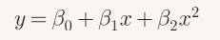
Step 2: Construct Dataset with Polynomial Features
We add (x^2) as an extra predictor:
(x) | (y) | (x^2)
1 | 2 | 1
2 | 6 | 4
3 | 14 | 9
4 | 28 | 16
5 | 45 | 25

Step 3: Fit the Model
Using least squares regression (solving normal equations):
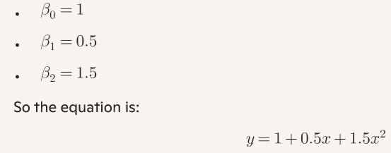
Step to Compute:


Point 3- How to compute Coefficients:
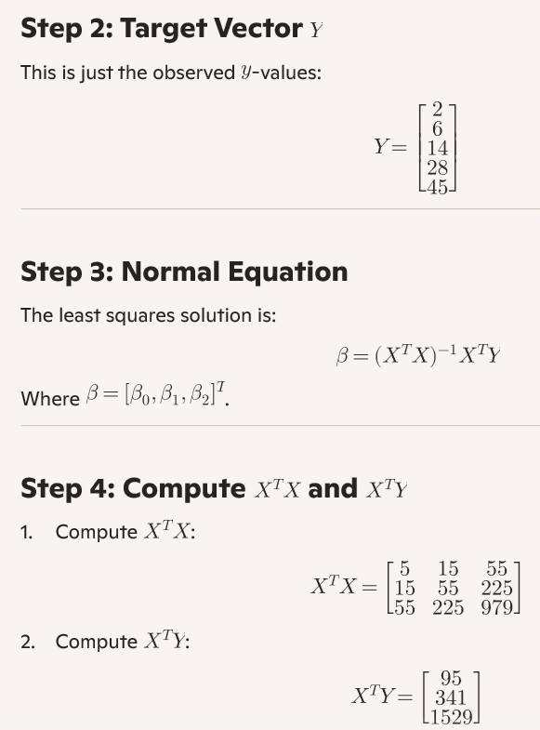

Find X^{T}X: ----
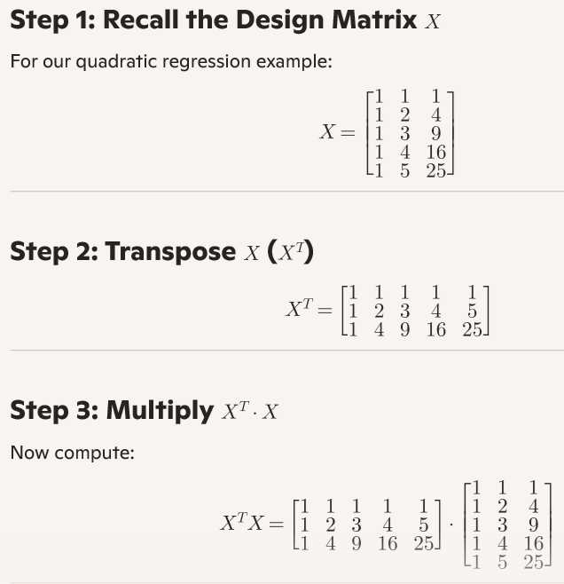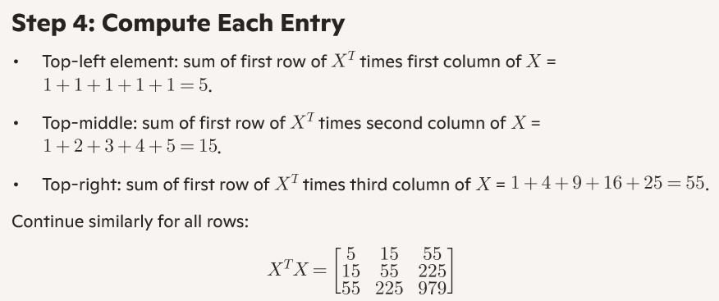

Step 4: Verify with Dataset
- For (x=1): (y = 1 + 0.5(1) + 1.5(1^2) = 3) (close to 2)
- For (x=2): (y = 1 + 1 + 6 = 8) (close to 6)
- For (x=3): (y = 1 + 1.5 + 13.5 = 16) (close to 14)
- For (x=4): (y = 1 + 2 + 24 = 27) (close to 28)
- For (x=5): (y = 1 + 2.5 + 37.5 = 41) (close to 45)
The model fits well.

Step 5: Prediction
If a student studies 6 hours:
y = 1 + 0.5(6) + 1.5(36) = 1 + 3 + 54 = 58
Predicted score = 58

Final Answer:
- Polynomial regression equation: y = 1 + 0.5x + 1.5x²
- Predicted score for 6 hours: 58

The Difference between linear regression and polynomial regression, with examples, applications, and guidance on choosing the right technique:

Differences:
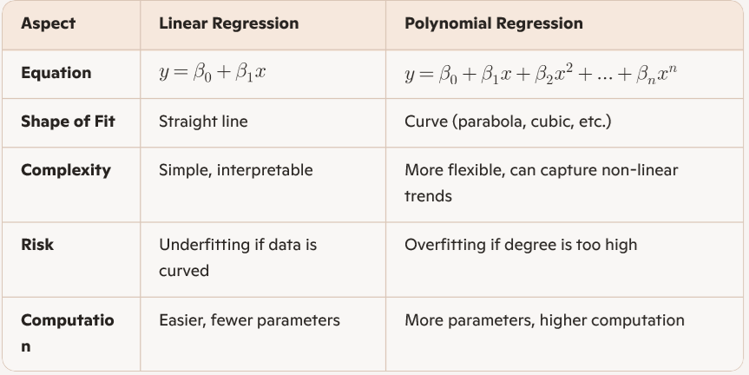
Example
- Linear Regression Example:
Predicting house price vs. square footage.
If the relationship is roughly straight-line, a linear model works:
Price = 50,000 + 200 . Square Feet
- Polynomial Regression Example:
Predicting student exam scores vs. study hours.
Scores may rise slowly at first, then sharply, then plateau. A quadratic fit works better:
Score = 1 + 0.5x + 1.5x²
Applications
- Linear Regression
  - Economics: income vs. years of experience
  - Engineering: temperature vs. resistance
  - Business: sales vs. advertising spend
- Polynomial Regression
  - Physics: motion trajectories (distance vs. time)
  - Medicine: drug dosage vs. patient response curve
  - Machine Learning: modeling complex non-linear relationships in datasets

How to Choose the Right Technique
- Visualize the Data
  - Plot (x) vs. (y).
  - If points roughly align in a straight line → use linear regression.
  - If points curve upward/downward → consider polynomial regression.
- Start Simple
  - Begin with linear regression.
  - Check residuals (errors). If they show a curved pattern, move to polynomial.
- Degree Selection
  - Use cross-validation or metrics (R², RMSE) to decide polynomial degree.
  - Avoid very high degrees (risk of overfitting).
  - Common practice: quadratic (degree 2) or cubic (degree 3) is often sufficient.
- Interpretability vs. Accuracy
  - If interpretability is important (e.g., economics), prefer linear.
  - If accuracy on curved data is critical (e.g., physics), use polynomial.

Conclusion:
- Linear regression fits straight-line relationships.
- Polynomial regression fits curved relationships.
- Choose based on data visualization, error analysis, and balance between simplicity and accuracy.

